

SCHOOL OF COMPUTING

Department of Computer Science and Engineering

CERTIFICATE

This is to certify that the Cornerstone project work entitled “Gym Membership Management System” is submitted by
R.P. UDAY KUMAR | (24B11CS814)
K.M. SHIVARANJITH KUMAR | (24B11CS361)
R. JAYANT | (24B11CS805)
C.RANJITH KUMAR | (24B11CS143)

in partial fulfillment of the requirements for the award of the B.Tech. degree in Computer Science and Engineering for the academic year 2026-2027.

Project Guide Head of the Department
Mrs. K Vydehi, M.Tech.,(Ph.D), Dr. Phani Sridhar Addepalli, Ph.D,
Assistant Professor, Assistant Professor,
Department of CSE Department of CSE

DECLARATION

We hereby declare that the Cornerstone project entitled “Gym Membership Management System” is original and is submitted to ADITYA UNIVERSITY, Surampalem, in partial fulfillment of the requirements for the award of the B.Tech. Degree in Computer Science and Engineering. We further declare that this project work has not been submitted, either in full or in part, for the award of any degree in this or any other institution. We also confirm that this work complies with the Institutional Academic Integrity and AI Usage Policy

Place: Surampalem
Date:
By
R.P. UDAY KUMAR | (24B11CS814)
K.M. SHIVARANJITH KUMAR | (24B11CS361)
R. JAYANTH | (24B11CS805)
C. RANJITH KUMAR | (24B11CS143)

ACKNOWLEDGEMENT

It is with immense pleasure that we express our sincere gratitude to our Cornerstone Project Guide, Mrs. K Vydehi, Assistant Professor, who has guided us throughout the project. Her valuable support, encouragement, and guidance have greatly contributed to the successful completion of this work.
We would like to thank our Deputy Heads of the Department, Dr. Chandra Sekhar Kolli, Associate Professor, Dr Hari Jyothula, Associate Professor and Dr Pennada Siva Satya Prasad, Assistant Profeesor, Department of Computer Science and Engineering, for their support and valuable suggestions.
Our deepest thanks to our Head of the Department Dr. Phani Sridhar Addepalli, Assistant Professor, for his inspiration and for providing all the necessary facilities and resources required for this project.
We also extend our sincere thanks to Dr. M.V. Rajesh, Associate Dean, School of Computing for their encouragement and support during the course of our project.
We would like to express our sincere gratitude to Dr. G. Suresh, Registrar, Dr. A Ramesh, Pro Vice-Chancellor (Engineering & Sciences), Dr. S. Rama Sree, Pro Vice-Chancellor (Academics), Dr. M.B. Srinivas, Vice-Chancellor, Dr. M. Sreenivasa Reddy, Deputy Pro Chancellor and Management, Aditya University for providing excellent infrastructure and state-of-the-art laboratories.
Finally, we would like to thank the faculty members, lab technicians, non-teaching staff, and our friends who have directly or indirectly supported us in completing this Cornerstone project successfully.

TABLE OF CONTENTS
1. Cover Page / Certificate ..................................................... 1
2. Declaration ................................................................. 2
3. Acknowledgement ............................................................. 3
4. Table of Contents ............................................................ 4
5. Abstract ..................................................................... 5
6. List of Figures .............................................................. 6
7. List of Tables ............................................................... 6
8. Acronyms ..................................................................... 6
1. Introduction ................................................................. 7
1.1 Brief Information about the Project ......................................... 7
1.2 Motivation and Contribution of Project ...................................... 7
1.3 Objectives of the Project ................................................... 7
1.4 Scope of the Project ........................................................ 7
2. System Analysis .............................................................. 8
2.1 Existing System ............................................................. 8
2.2 Proposed System ............................................................. 8
2.3 Functional Requirements ..................................................... 8
2.4 Non-Functional Requirements ................................................. 8
2.5 Requirements Specification .................................................. 9
3. Database Design ............................................................. 10
3.1 Major Entities ............................................................. 10
3.2 ER Model ................................................................... 10
3.3 Relationships .............................................................. 10
4. ER Diagram .................................................................. 11
5. Relational Schema ........................................................... 12
6. Table Design ................................................................ 13
7. Normalization ............................................................... 15
8. SQL Implementation .......................................................... 16
8.1 DDL – Data Definition Language ............................................. 16
8.2 DML – Data Manipulation Language ........................................... 17
8.3 DQL – Data Query Language .................................................. 17
9. SQL Queries & Outputs ....................................................... 18
10. Conclusion ................................................................. 26
11. Future Enhancements ........................................................ 26
12. References ................................................................. 26

ABSTRACT
The Gym Membership Management System is designed to manage gym members, membership plans, payments, attendance, trainers, and workout schedules through a centralized relational database. The system stores member and trainer information, handles multiple phone numbers using separate relations, records membership assignments, payment transactions, attendance entries, and trainer-conducted workouts. Primary keys, foreign keys, NOT NULL and CHECK constraints maintain data integrity. The database is normalized up to Third Normal Form (3NF) to reduce redundancy and update anomalies. SQL queries support member lookup, membership tracking, payment analysis, attendance retrieval, workout reporting, and derived age calculation.
Keywords: Gym Management, Relational Database, ER Diagram, Normalization, SQL, Oracle, Membership System, DBMS.

LIST OF FIGURES
Figure 1. ER Diagram of Gym Membership Management Database
Figure 2. Proposed Database Application Structure (conceptual)
LIST OF TABLES
Table 1. Major Database Entities
Table 2. Functional Requirements
Table 3. Member Table Structure
Table 4. Trainer Table Structure
Table 5. Membership Table Structure
Table 6. Payment Table Structure
Table 7. Attendance Table Structure
Table 8. Workout Table Structure
Table 9. Keys and Constraints
Table 10. Relational Schema Summary
ACRONYMS
DBMS – Database Management System
ER – Entity Relationship
SQL – Structured Query Language
DDL – Data Definition Language
DML – Data Manipulation Language
DQL – Data Query Language
PK – Primary Key
FK – Foreign Key
1NF – First Normal Form
2NF – Second Normal Form
3NF – Third Normal Form
DOB – Date of Birth
UPI – Unified Payments Interface

1. INTRODUCTION

1.1 Brief Information about the Project
A Gym Membership Management System is a database application that manages member registration, membership plans, payments, attendance, trainers, and workout schedules. The project provides a centralized relational database that replaces scattered manual records and supports consistent storage and efficient retrieval of gym information. The system is implemented using Oracle SQL with proper primary keys, foreign keys, and integrity constraints.

1.2 Motivation and Contribution of Project
The project is motivated by common problems in gym management such as maintaining member records manually, tracking membership validity, recording payments, monitoring attendance, and maintaining trainer and workout details. A centralized database provides a systematic way to store related information and enforce relationships through keys and constraints.
- Centralizing gym records in one relational database.
- Reducing duplicate and inconsistent member information.
- Maintaining referential integrity using primary and foreign keys.
- Supporting faster membership, payment, attendance, and workout queries.
- Providing a structured foundation for gym administration and reporting.

1.3 Objectives of the Project
- Develop a centralized gym membership database.
- Manage member personal details and phone numbers.
- Maintain trainer information and trainer phone numbers.
- Store membership plan and validity details.
- Record member payments and payment modes.
- Maintain attendance records and check-in information.
- Store workout schedules conducted by trainers.
- Reduce duplicate data and update anomalies through normalization.
- Support efficient SQL queries and reports.

1.4 Scope of the Project
The scope covers database-oriented management of gym members, trainers, memberships, payments, attendance, and workouts. The system can serve as the backend for a gym administration application and can be extended later with equipment tracking, diet plans, trainer performance, notifications, online payments, and a web or mobile interface.
2. SYSTEM ANALYSIS

2.1 Existing System
- Manual member record maintenance.
- Separate notebooks or spreadsheet files for members and payments.
- Duplicate member and trainer information.
- Time-consuming searches for active memberships and payment history.
- Difficulty in tracking attendance and workout schedules.
- Higher possibility of data-entry errors and inconsistent records.

2.2 Proposed System
The proposed system uses a centralized relational database. It organizes gym information into related tables and uses primary keys, foreign keys, NOT NULL conditions, and CHECK constraints. Multivalued phone numbers are represented through separate MEMBER_PHONE and TRAINER_PHONE relations. The system supports member, membership, payment, attendance, trainer, and workout management.
- Centralized gym database
- Member, membership, payment, attendance, trainer, and workout management
- SQL-based reporting and referential integrity

2.3 Functional Requirements
Module | Functional Requirement
Member Management | Add, update, search, and display member details.
Membership Management | Store membership plans, start dates, end dates, and assigned dates.
Payment Management | Record payment amount, payment date, and payment mode.
Attendance Management | Record attendance date, check-in value, and check-in type.
Trainer Management | Store trainer details and specialization.
Workout Management | Maintain workout type, duration, and workout dates.
Search and Reporting | Retrieve and summarize gym information using SQL queries.

2.4 Non-Functional Requirements
Performance – queries should return results efficiently for normal gym workloads.
Integrity – invalid references and duplicate key values should be prevented.
Security – database access should be controlled for authorized users.
Usability – records and reports should be understandable to gym staff.
Reliability – transactions should preserve a consistent database state.
Scalability – the design should support growth in members, payments, and attendance records.

2.5 Requirements Specification
Category | Suggested Requirement
Hardware | Intel i3 or above; 4 GB RAM minimum; adequate storage; standard display and keyboard/mouse.
Operating System | Windows 10/11 or an equivalent supported platform.
Database | Oracle Database / Oracle SQL environment used for the implementation.

3. DATABASE DESIGN

3.1 Major Entities
Entity | Description
MEMBER | Stores member personal details and date of birth.
TRAINER | Stores trainer name and specialization.
MEMBERSHIP | Stores plans and membership validity for members.
PAYMENT | Stores member payment transactions.
ATTENDANCE | Stores member attendance and check-in information.
WORKOUT | Stores workouts conducted by trainers.

3.2 ER Model
The ER model represents six main entities and their relationships. MEMBER contains a composite Name attribute represented as FirstName and LastName, a multivalued Phone attribute, and a derived Age attribute calculated from DOB. TRAINER also has a multivalued Phone attribute. The relational conversion creates separate MEMBER_PHONE and TRAINER_PHONE tables for these multivalued attributes.

3.3 Relationships
Relationship | Description
MEMBER → MEMBERSHIP (HAS) | One member can have many membership records (1:N).
MEMBER → PAYMENT (MAKES) | One member can make many payments (1:N).
MEMBER → ATTENDANCE (RECORDS) | One member can have many attendance records (1:N).
TRAINER → WORKOUT (CONDUCTS) | One trainer can conduct many workouts (1:N).

4. ER DIAGRAM
Figure 1: ER Diagram of Gym Membership Management Database
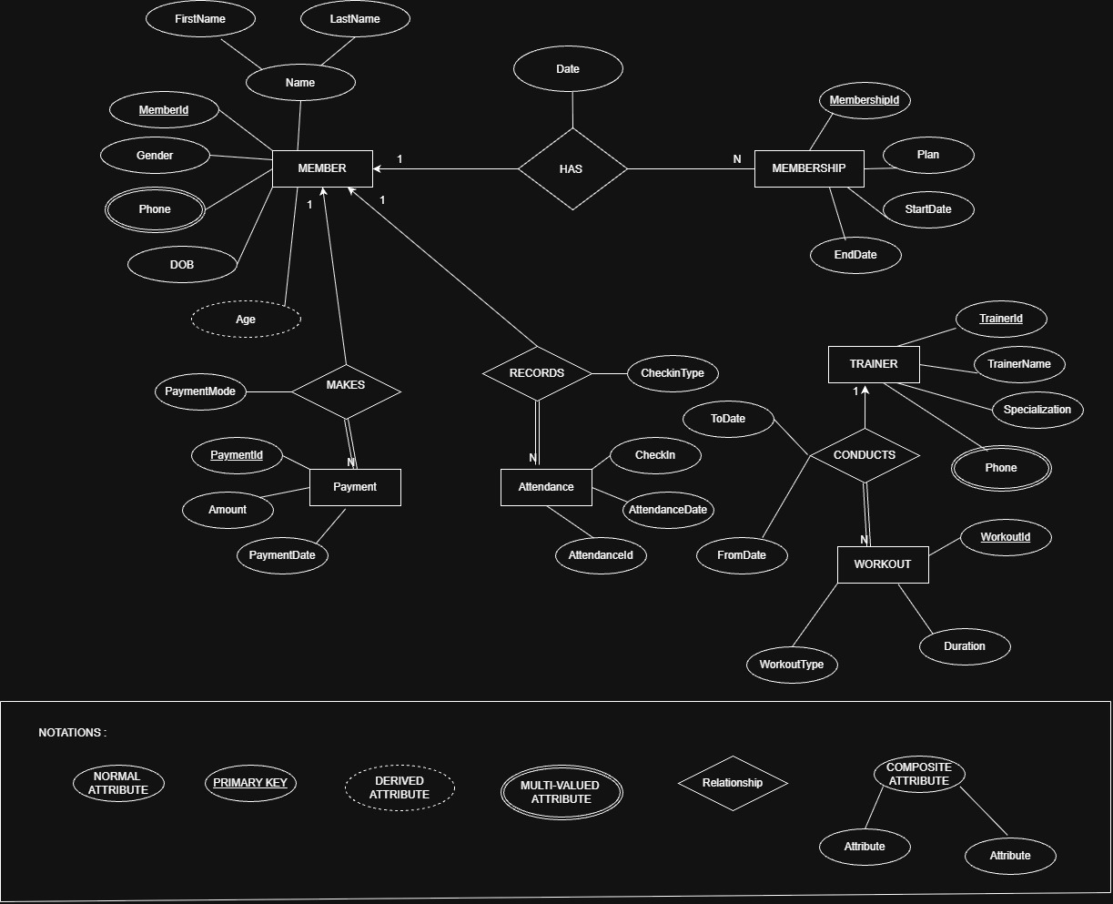
The ER diagram represents the entities, attributes, relationships, and 1:N cardinalities used in the implemented gym database. Multivalued phone attributes are converted into separate relations during relational mapping, while Age is derived from DOB and is not stored as a separate column. Composite Name is shown with FirstName and LastName components.

5. RELATIONAL SCHEMA
Relation | Relational Schema
MEMBER | MemberID (PK), FirstName, LastName, Gender, DOB
MEMBER_PHONE | MemberID (PK/FK), Phone (PK)
TRAINER | TrainerID (PK), TrainerName, Specialization
TRAINER_PHONE | TrainerID (PK/FK), Phone (PK)
MEMBERSHIP | MembershipID (PK), MemberID (FK), Plan, StartDate, EndDate, AssignedDate
PAYMENT | PaymentID (PK), MemberID (FK), Amount, PaymentDate, PaymentMode
ATTENDANCE | AttendanceID (PK), MemberID (FK), AttendanceDate, CheckIn, CheckInType
WORKOUT | WorkoutID (PK), TrainerID (FK), WorkoutType, Duration, FromDate, ToDate
The relational schema contains eight tables. MEMBER_PHONE and TRAINER_PHONE are created because Phone is multivalued in the ER model. MEMBERSHIP, PAYMENT, and ATTENDANCE reference MEMBER, while WORKOUT references TRAINER. Primary and foreign keys preserve the relationships between the tables.

6. TABLE DESIGN

6.1 Member Table
Attribute | Data Type | Constraint | Description
MemberID | NUMBER | PK, NOT NULL | Unique member identifier
FirstName | VARCHAR2(30) | NOT NULL | Member first name
LastName | VARCHAR2(30) | NOT NULL | Member last name
Gender | VARCHAR2(10) | — | Member gender
DOB | DATE | NOT NULL | Date of birth

6.2 Trainer Table
Attribute | Data Type | Constraint | Description
TrainerID | NUMBER | PK, NOT NULL | Unique trainer identifier
TrainerName | VARCHAR2(40) | NOT NULL | Trainer name
Specialization | VARCHAR2(40) | — | Trainer specialization

6.3 Membership Table
Attribute | Data Type | Constraint | Description
MembershipID | NUMBER | PK | Unique membership identifier
MemberID | NUMBER | FK, NOT NULL | References MEMBER
Plan | VARCHAR2(20) | NOT NULL | Membership plan
StartDate | DATE | NOT NULL | Membership start date
EndDate | DATE | NOT NULL | Membership end date
AssignedDate | DATE | — | Date membership was assigned

6.4 Payment Table
Attribute | Data Type | Constraint | Description
PaymentID | NUMBER | PK | Unique payment identifier
MemberID | NUMBER | FK, NOT NULL | References MEMBER
Amount | NUMBER(10,2) | CHECK > 0 | Payment amount
PaymentDate | DATE | NOT NULL | Payment date
PaymentMode | VARCHAR2(20) | — | Cash, UPI, Card, etc.

6.5 Attendance Table
Attribute | Data Type | Constraint | Description
AttendanceID | NUMBER | PK | Unique attendance identifier
MemberID | NUMBER | FK, NOT NULL | References MEMBER
AttendanceDate | DATE | NOT NULL | Attendance date
CheckIn | VARCHAR2(10) | — | Check-in value
CheckInType | VARCHAR2(20) | — | Type of check-in

6.6 Workout Table
Attribute | Data Type | Constraint | Description
WorkoutID | NUMBER | PK | Unique workout identifier
TrainerID | NUMBER | FK, NOT NULL | References TRAINER
WorkoutType | VARCHAR2(30) | — | Type of workout
Duration | NUMBER | CHECK > 0 | Workout duration in minutes
FromDate | DATE | — | Workout start date
ToDate | DATE | CHECK | Workout end date

6.7 Keys and Constraints
Constraint Type | Applied To / Purpose
Primary Key | Uniquely identifies rows in all main and phone tables.
Foreign Key | Connects phone, membership, payment, attendance, and workout records to their parent tables.
NOT NULL | Used for required identifiers, names, dates, and relationship attributes.
CHECK | EndDate >= StartDate; Amount > 0; Duration > 0; ToDate >= FromDate.
Composite Key | (MemberID, Phone) and (TrainerID, Phone) prevent duplicate phone records.
Note: Age is a derived attribute calculated from DOB, so it is not stored in MEMBER. Phone is multivalued in the ER model and is therefore stored in separate phone relations.

7. NORMALIZATION
Normalization organizes the gym data into related relations to reduce redundancy and update anomalies. The final database is designed up to Third Normal Form (3NF).

7.1 Unnormalized Form (UNF)
A single unnormalized gym record could contain MemberID, member name, multiple phone numbers, membership details, payment details, attendance details, trainer details, and workout details together. Repeating phone, payment, and attendance information would create redundancy.

7.2 First Normal Form (1NF)
In 1NF, repeating groups are removed and every attribute contains an atomic value. Since a member may have multiple phone numbers, phone values are separated into MEMBER_PHONE. Trainer phone values are similarly separated into TRAINER_PHONE.

7.3 Second Normal Form (2NF)
In 2NF, attributes must depend on the complete primary key. Member details depend on MemberID, trainer details on TrainerID, membership details on MembershipID, and transaction details on their own identifiers. Separate relations remove partial dependencies.

7.4 Third Normal Form (3NF)
In 3NF, transitive dependencies are removed. Member information is stored only in MEMBER, trainer information only in TRAINER, and transaction-specific information is stored in MEMBERSHIP, PAYMENT, ATTENDANCE, and WORKOUT. Phone numbers are separated into their own relations. Thus non-key attributes depend only on their table's primary key.
Relation | Reason for Separation
MEMBER | Stores member-specific attributes once.
MEMBER_PHONE | Stores multiple phone numbers without repeating columns.
TRAINER | Stores trainer-specific attributes once.
TRAINER_PHONE | Stores multiple trainer phone numbers separately.
MEMBERSHIP / PAYMENT / ATTENDANCE | Store separate member-related transaction and activity information.
WORKOUT | Stores workout information related to a trainer.

8. SQL IMPLEMENTATION
The following Oracle SQL implementation creates the eight relational tables obtained from the ER-to-relational mapping. The schema uses primary keys, foreign keys, NOT NULL and CHECK constraints.

8.1 DDL – Data Definition Language
CREATE TABLE MEMBER (
MemberID NUMBER PRIMARY KEY,
FirstName VARCHAR2(30) NOT NULL,
LastName VARCHAR2(30) NOT NULL,
Gender VARCHAR2(10),
DOB DATE NOT NULL
);

CREATE TABLE TRAINER (
TrainerID NUMBER PRIMARY KEY,
TrainerName VARCHAR2(40) NOT NULL,
Specialization VARCHAR2(40)
);

CREATE TABLE MEMBER_PHONE (
MemberID NUMBER,
Phone VARCHAR2(15),
PRIMARY KEY (MemberID, Phone),
FOREIGN KEY (MemberID) REFERENCES MEMBER(MemberID)
);

CREATE TABLE TRAINER_PHONE (
TrainerID NUMBER,
Phone VARCHAR2(15),
PRIMARY KEY (TrainerID, Phone),
FOREIGN KEY (TrainerID) REFERENCES TRAINER(TrainerID)
);

CREATE TABLE MEMBERSHIP (
MembershipID NUMBER PRIMARY KEY,
MemberID NUMBER NOT NULL,
Plan VARCHAR2(20) NOT NULL,
StartDate DATE NOT NULL,
EndDate DATE NOT NULL,
AssignedDate DATE,
FOREIGN KEY (MemberID) REFERENCES MEMBER(MemberID),
CHECK (EndDate >= StartDate)
);

CREATE TABLE PAYMENT (
PaymentID NUMBER PRIMARY KEY,
MemberID NUMBER NOT NULL,
Amount NUMBER(10,2) NOT NULL,
PaymentDate DATE NOT NULL,
PaymentMode VARCHAR2(20),
FOREIGN KEY (MemberID) REFERENCES MEMBER(MemberID),
CHECK (Amount > 0)
);

CREATE TABLE ATTENDANCE (
AttendanceID NUMBER PRIMARY KEY,
MemberID NUMBER NOT NULL,
AttendanceDate DATE NOT NULL,
CheckIn VARCHAR2(10),
CheckInType VARCHAR2(20),
FOREIGN KEY (MemberID) REFERENCES MEMBER(MemberID)
);

CREATE TABLE WORKOUT (
WorkoutID NUMBER PRIMARY KEY,
TrainerID NUMBER NOT NULL,
WorkoutType VARCHAR2(30),
Duration NUMBER,
FromDate DATE,
ToDate DATE,
FOREIGN KEY (TrainerID) REFERENCES TRAINER(TrainerID),
CHECK (Duration > 0),
CHECK (ToDate >= FromDate)
);

8.2 DML – Data Manipulation Language
Fifteen sample records were inserted into each of the eight tables. Oracle INSERT ALL is used to insert multiple records efficiently. Example inserts:
INSERT ALL
INTO MEMBER VALUES (101, 'Rahul', 'Sharma', 'Male', DATE '2004-05-12')
INTO MEMBER VALUES (102, 'Priya', 'Reddy', 'Female', DATE '2003-08-21')
INTO MEMBER VALUES (103, 'Arjun', 'Kumar', 'Male', DATE '2005-01-15')
-- Remaining sample rows are included in the project SQL script
SELECT * FROM DUAL;
COMMIT;

8.3 DQL – Data Query Language
SELECT * FROM MEMBER;
SELECT FirstName, LastName FROM MEMBER WHERE Gender = 'Female';
SELECT M.FirstName, MS.Plan FROM MEMBER M JOIN MEMBERSHIP MS ON M.MemberID = MS.MemberID;
SELECT M.FirstName, P.Amount FROM MEMBER M JOIN PAYMENT P ON M.MemberID = P.MemberID;
SELECT T.TrainerName, W.WorkoutType FROM TRAINER T JOIN WORKOUT W ON T.TrainerID = W.TrainerID;
SELECT SUM(Amount) AS Total_Payment FROM PAYMENT;
SELECT COUNT(*) AS Total_Members FROM MEMBER;
SELECT FirstName, LastName, TRUNC(MONTHS_BETWEEN(SYSDATE, DOB) / 12) AS Age FROM MEMBER;

9. SQL QUERIES & RESULTS
The following SQL queries demonstrate selection, filtering, joins, aggregation, derived values, sorting, grouping, and validation of the gym database. Oracle screenshots of actual outputs can be inserted by the project team below each query description.
Q1. Display all members
SELECT * FROM MEMBER;
Output: Shows all member records.
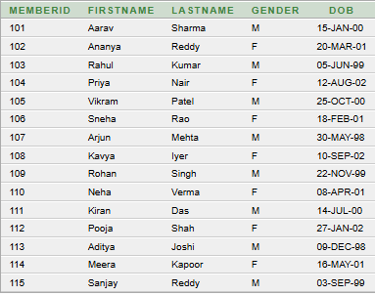
Q2. Display female members
SELECT FirstName, LastName FROM MEMBER WHERE Gender = 'F';
Output: Shows members whose Gender is Female.
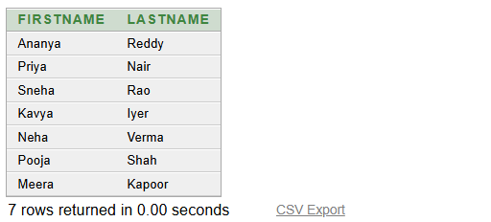
Q3. Display member names and membership plans
SELECT M.FirstName, MS.Plan FROM MEMBER M JOIN MEMBERSHIP MS ON M.MemberID = MS.MemberID;
Output: Combines MEMBER and MEMBERSHIP using MemberID.
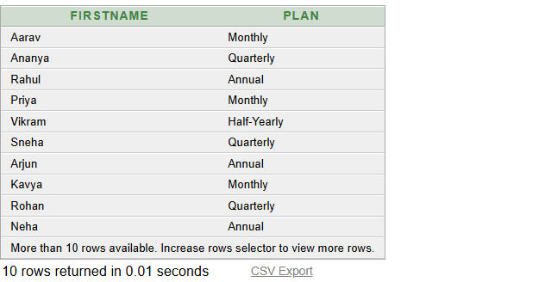
Q4. Display member names and payment amounts
SELECT M.FirstName, P.Amount FROM MEMBER M JOIN PAYMENT P ON M.MemberID = P.MemberID;
Output: Shows each member with the related payment amount.
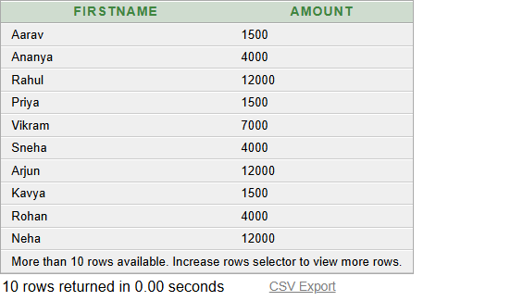
Q5. Display trainer names and workout types
SELECT T.TrainerName, W.WorkoutType FROM TRAINER T JOIN WORKOUT W ON T.TrainerID = W.TrainerID;
Output: Shows the workouts conducted by trainers.
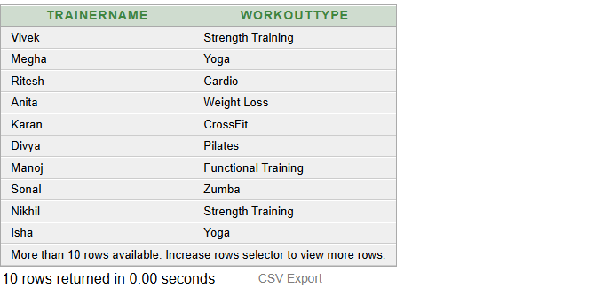
Q6. Find total payment
SELECT SUM(Amount) AS Total_Payment FROM PAYMENT;
Output: Returns the total payment amount.
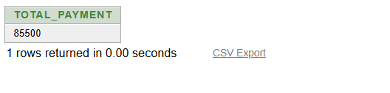
Q7. Find average payment
SELECT AVG(Amount) AS Average_Payment FROM PAYMENT;
Output: Returns the average payment amount.
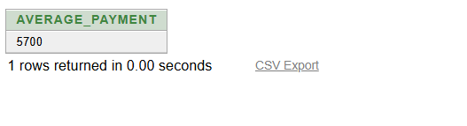
Q8. Count total members
SELECT COUNT(*) AS Total_Members FROM MEMBER;
Output: Returns the total number of members.
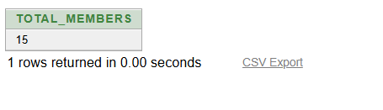
Q9. Calculate member age from DOB
SELECT FirstName, LastName, DOB, TRUNC(MONTHS_BETWEEN(SYSDATE, DOB) / 12) AS Age FROM MEMBER;
Output: Calculates age dynamically from DOB.
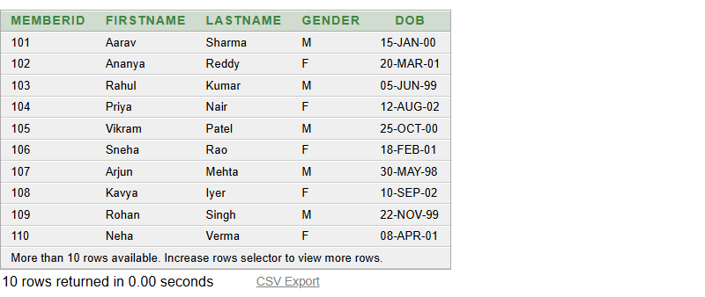
Q10. Display payments greater than 3000
SELECT M.FirstName, P.Amount FROM MEMBER M JOIN PAYMENT P ON M.MemberID = P.MemberID WHERE P.Amount > 3000;
Output: Shows payments above 3000.
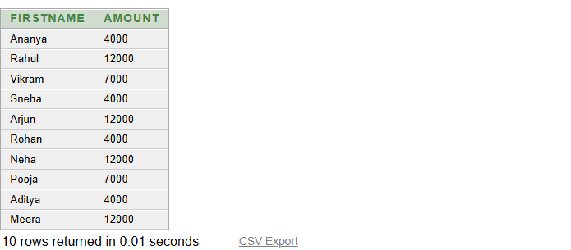
Q11. Display UPI payments
SELECT PaymentID, Amount, PaymentDate FROM PAYMENT WHERE PaymentMode = 'UPI';
Output: Filters payment records using PaymentMode.
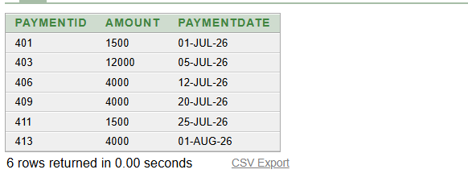
Q12. Display workouts longer than 45 minutes
SELECT WorkoutType, DurationWeeks FROM WORKOUT WHERE DurationWeeks > 45;
Output: Shows workouts longer than 45 minutes.
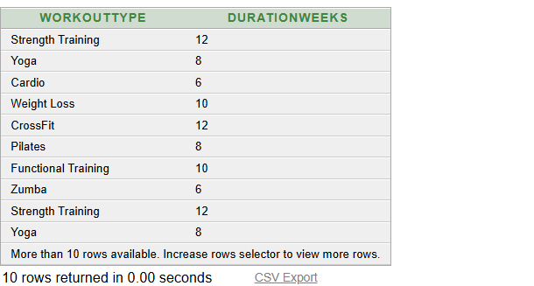
Q13. Display member phone numbers
SELECT M.FirstName, MP.Phone FROM MEMBER M JOIN MEMBER_PHONE MP ON M.MemberID = MP.MemberID;
Output: Shows multivalued member phone information.
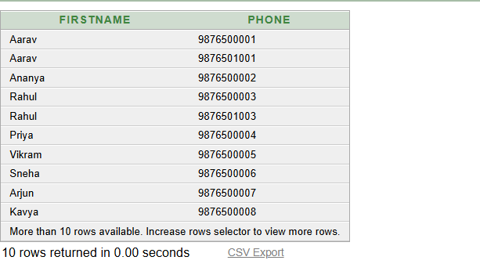
Q14. Display trainer phone numbers
SELECT T.TrainerName, TP.Phone FROM TRAINER T JOIN TRAINER_PHONE TP ON T.TrainerID = TP.TrainerID;
Output: Shows trainer phone numbers.
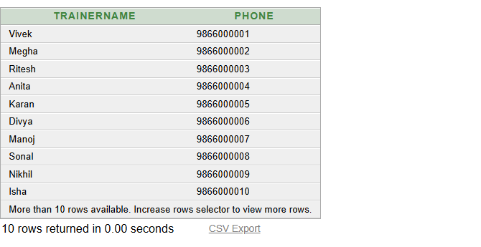
Q15. Display members alphabetically
SELECT FirstName, LastName FROM MEMBER ORDER BY FirstName;
Output: Sorts member names in ascending order.
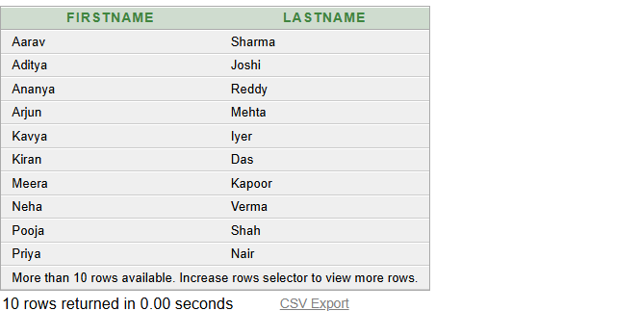
Q16. Count members by gender
SELECT Gender, COUNT(*) AS Total FROM MEMBER GROUP BY Gender;
Output: Groups members by gender.
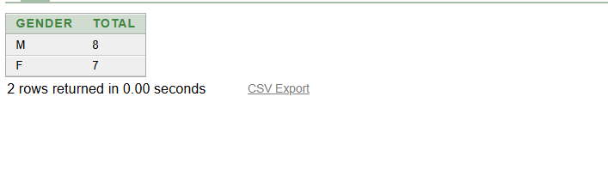
Q17. Total payment by payment mode
SELECT PaymentMode, SUM(Amount) AS Total FROM PAYMENT GROUP BY PaymentMode;
Output: Calculates totals for each payment mode.
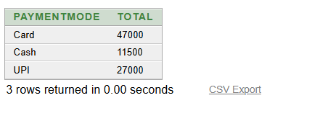
Q18. Count workouts for each trainer
SELECT T.TrainerName, COUNT(W.WorkoutID) AS Total_Workouts FROM TRAINER T JOIN WORKOUT W ON T.TrainerID = W.TrainerID GROUP BY T.TrainerName;
Output: Counts workouts conducted by each trainer.
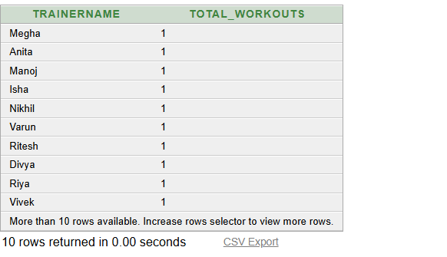
Q19. Find highest payment
SELECT MAX(Amount) AS Highest_Payment FROM PAYMENT;
Output: Returns the highest payment.
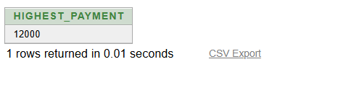
Q20. Find lowest payment
SELECT MIN(Amount) AS Lowest_Payment FROM PAYMENT;
Output: Returns the lowest payment.
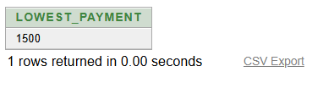
Q21. Display monthly memberships
SELECT M.FirstName, MS.Plan FROM MEMBER M JOIN MEMBERSHIP MS ON M.MemberID = MS.MemberID WHERE MS.Plan = 'Monthly';
Output: Shows members having a Monthly plan.
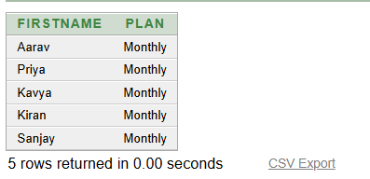
Q22. Display attendance records
SELECT M.FirstName, A.AttendanceDate FROM MEMBER M JOIN ATTENDANCE A ON M.MemberID = A.MemberID;
Output: Shows attendance dates for members.
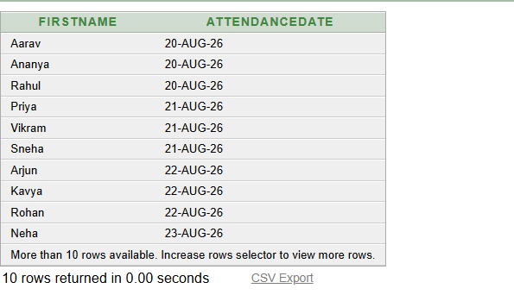
Q23. Display membership validity
SELECT M.FirstName, MS.StartDate, MS.EndDate FROM MEMBER M JOIN MEMBERSHIP MS ON M.MemberID = MS.MemberID;
Output: Shows membership start and end dates.
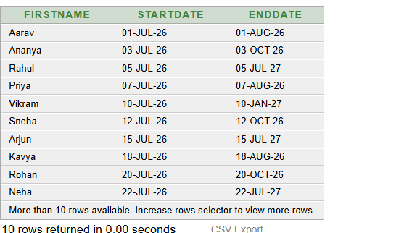
Q24. Verify record counts in every table
SELECT 'MEMBER' AS Table_Name, COUNT(*) AS Total FROM MEMBER UNION ALL SELECT 'MEMBER_PHONE', COUNT(*) FROM MEMBER_PHONE UNION ALL ... (similar for all 8 tables);
Output: Verifies row counts in all eight tables.
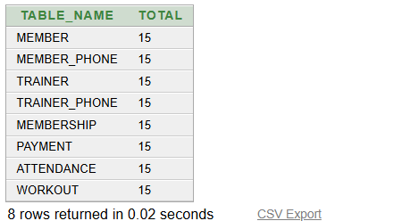
Q25. Display one member using primary key
SELECT * FROM MEMBER WHERE MemberID = 101;
Output: Retrieves the member whose primary key is 101.
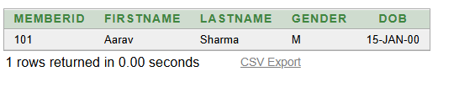

10. CONCLUSION
The Gym Membership Management System provides a structured relational database for managing members, memberships, payments, attendance, trainers, and workouts. The implementation uses eight normalized tables with primary and foreign keys, CHECK constraints, and separate relations for multivalued phone numbers. The SQL queries demonstrate retrieval, filtering, joins, aggregation, grouping, and derived age calculation. The design satisfies the DBMS project requirements and provides a foundation for future gym administration applications.

11. FUTURE ENHANCEMENTS
- Role-based access for gym administrators, trainers, and authorized staff.
- Online membership renewal and payment integration.
- Attendance dashboards and monthly activity reports.
- Equipment and maintenance management.
- Trainer schedules, workout plans, and progress tracking.
- Automated reminders for membership expiry and payments.

12. REFERENCES
1. Korth, H. F., Silberschatz, A., and Sudarshan, S., Database System Concepts, McGraw Hill.
2. Elmasri, R. and Navathe, S. B., Fundamentals of Database Systems, Pearson.
3. Oracle Database SQL Language Reference (Oracle Corporation).

